Biggin C of E Primary School

Newsletter 3 for Autumn Term One: 4th September - 26th October 2018 Published Monday 17th September 2018

What a brilliant week we have all enjoyed. It is a real joy to see the children coming in with such smiling faces and ready to learn.
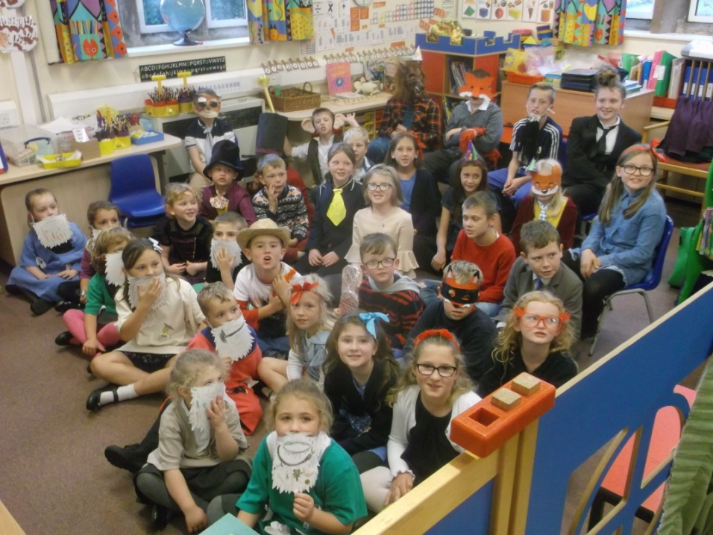
The highlight had to be the whole school enjoying our Roald Dahl Day on Friday. Well done to all the children (and staff!) for their creativity with their outfits. Everyone looked amazing. We had such a lot of fun baking cakes in Key Stage 1 for everyone to enjoy at the party at the end of the day. In Key Stage 2, children made films telling the stories of Roald Dahl's life and Fantastic Mr Fox and worked on science involving giant peaches and marvellous medicines!

Derby County After School Club started very enthusiastically this week and Music Club led by Mrs Claire Kilner will start on Wednesday. We are so lucky to have two exciting clubs run by professionals taking place after school. Also, STEM club starts this week and Construction club will start on 25th September. There are still places available for Claire’s Music club if you haven't yet signed up.
This week we look forward to children taking part in Cross Country at QEGS after school on Monday and our Year 6 children will be having fun at White Hall from Wednesday onwards.
Remember to keep Friday morning, 28th September free to pop into pre-school for the Macmillan coffee morning. You will also be able to join the rest of school afterwards for the mass warm-up for Stand Up Derbyshire to burn off the extra calories from the cake!
Best wishes
Teresa Nicholls

Congratulations to Gordon Wilton who has won the first Bonus Ball draw with number 44 on Saturday 15th September. We do have a couple of ‘free’ numbers if you would like to join in? Payment is due in advance, either weekly, monthly or however you prefer. You may also pay by cheque (to Biggin School) or by cash. Thank you.

Reminders for this week: 17th – 23rd September
Monday After-school STEM club
Wednesday Y6 off to Whitehall
After-school music club for those in years 4 – 6
Thursday ‘Show & Tell’ for Ruby, Brooke and Alivia
After-school sport coaching for those in years 1 - 6
Friday Y6 return from White Hall

Next week:
Monday 24th Swimming starts (1st of 10 lessons) for years 3 – 6
Finance Committee meeting
Tuesday 1st After-school Construction club for those who requested a place
Y6 to Q.E.G.S. Open Evening 5pm – 7pm
Friday Macmillan Coffee Morning

Dates for clubs starting later in the year
- After-school craft club will be for year 6 only on Fridays 5th, 12th and 19th October
- In-school (lunchtime) music club will run during Autumn 2, Spring 1 and Spring 2 terms (opposite to after-school sport club)

Dinner money has increased slightly to £2.10 per day. It should be paid in advance please either by cash or a cheque made payable to DCC. Autumn term 1 is £81.90 or £10.50 the following 7 weeks.

To contact school and/or reply to messages: - send a note via pupil-post (or leave it in the letter-box), email info@biggin.derbyshire.sch.uk, pop into the office, or leave a ‘phone message on 01298 84279

Please see the school’s website on www.biggin.derbyshire.sch.uk for the weekly newsletter, calendar and lots of information. Let us know there anything you can’t find.

Community Notices:

Biggin Poppy Festival needs you!
St Thomas's will be open during the 1st week in November to commemorate the Fallen on Biggin's war memorial. We would like to fill the church with as many poppies as possible. Can you knit or crochet? Patterns can be collected from Mary at school. Poppies made from other materials would be very welcome as well.
Do you have any photographs of the men named on the war memorial? Please could St Thomas's have a copy? Also any other information or images about men and women who served during the World Wars would be really helpful. Information and photos can be left at school or given to Kay Clayton, Rita Lamb or Julia Hewgill.
The church will be open from the 4th November for a week. There will be refreshments available on the 10th of November. The Armistice Service is at 2.30p.m on Sunday 11th November. If you would like to make poppies of any kind or have time to spare on the afternoon of the 10th please speak to Kay, Rita or Julia.

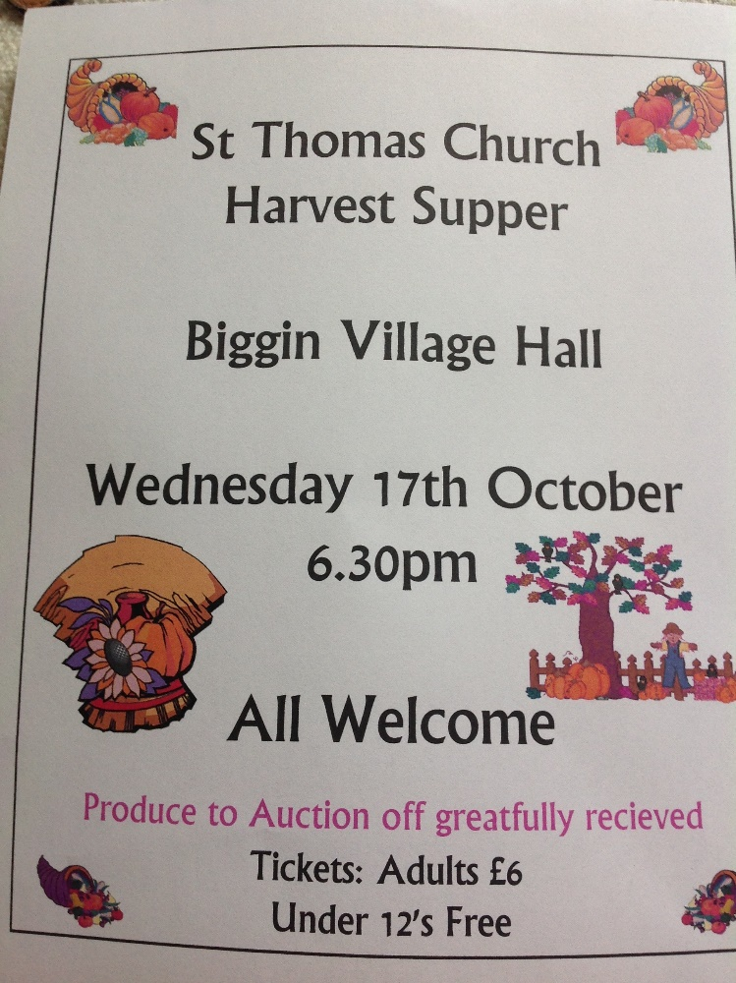

Safety Notice

Please remember: - small batteries will soon be around in all sorts of season items (Christmas jumpers and lights, Halloween things, etc). These can be dangerous. It is dangerous to swallow foreign object but also a battery will react with bodily fluid and cause internal burns which can be fatal. Please take care

If you have a bonus ball number, are you quite happy for your name to be printed on the weekly newsletter whenever you win? Please be aware that the newsletter is: -
- printed out and given in paper form to those who request it
- is uploaded and sent to private emails (addresses are not shared with anyone)
- is uploaded onto our website which is accessible to anyone at all with internet access

If you do not agree, please let the office know a.s.a.p.
If you do agree, please sign this slip and return to school a.s.a.p. I allow Biggin CE Primary to publish my name whenever my number wins (print your name as you wish it to appear)

__________________________________ signed ____________________________ dated__________

A few dates for your diary:

September
19th Y6 to Whitehall
21st Y6 return
24th KS2 swimming each week to 10/12/18
26th European Day of Languages
28th Macmillan coffee morning

October
2nd Beaumont/Starlight collection
1.15pm Wrates (school photos)
5th MAST assembly ‘a harvest story’
6th Country & Western evening (tickets
available from school)
10th library van due to call
17th St Thomas Harvest Supper
26th 9.00am church service
break up for the half-term holiday

November
5th school re-opens
7th library van due to call

December
6th library van due to call
18th Christmas concert
19th Christmas lunch in the village hall
20th Pantomime at Buxton Opera House
21st Christmas party
break up for the Christmas holiday

Return to school Monday 7th January 2019

Ashbourne junior hockey training – Wednesdays Q.E.G.S. astro pitch £2/week, call Helen on 07823 776256 – bring gum shield and shin pads, spare junior sticks available to use.

Ashbourne netball club - Ashbourne Leisure Centre term time Yrs 5 & 6 Thursdays 4pm – 5pm, Yrs 7 & 8 Thursday 5pm – 6pm, Y9 Wednesdays 4.30pm – 5.30pm

Ashbourne rugby club – www.ashbournerufc.co.uk for information & fixtures or call Martin Fryer on 07791 621927 for training.
Ashbourne recreation ground
- Saturdays for adults – or join them in the Club House (Ex-servicemen’s club)
- Sunday training sessions for juniors 10.30

Governor meetings 3.45pm
Finance committee
Monday 24th September

Full/AGM:
Wednesday 3rd October

‘Show and Tell’ rota Autumn 1
September
20th Ruby, Brooke & Alivia
27th Harvey
October
4th Daisy
11th Edie, Charlie & Amy
18th Ebony
25th Archie, Chloe-Mae & Isabelle
November
8th Finley
15th Sophia, Jorge & Eleanor
22nd Erynn
29rd Eddy, Ethan & Elsie
December
6th Jacob W, Harry & Casey
13th Chloe, Carrie & Jacob S

Yr6 twenty minute presentation
All others to talk about one item for five minutes

Please note reception children will be on the list from January 2019 to give them time to see how it wo

