Biggin C of E Primary School

Newsletter for the second Spring Term (25/02/19 – 12/04/19)
Published Monday 8th April 2019

Thank you for all your support this term ensuring that your children arrive at school ready to learn as well as the feedback from the parents’ questionnaires and attending the parent consultations. It’s certainly been a full half term and we are looking forward to an exciting week before we finish for a well-deserved break.

On Wednesday there is an African Day of dance, music and culture for the children to enjoy and on Friday we will complete the term with a visit to church to celebrate Easter. The children have been working hard on Drama and singing and some will be reading, too. Join us at 9.15am at the church if you can.

On Thursday after school I am holding a brief session for parents from 3.45pm – 4.45pm. This is partly an information session on helping your child stay safe online and how our Accelerated Scheme works and partly consultation about the development of our wider curriculum.

Mrs Woodroffe has decided that she would like to retire from the end of July this year. This is of course lovely for her but a little sad for us. She is an incredible help in school and does such a lot for the children, staff, school and the community as well as being brilliant at her job and at keeping school running smoothly. She will be very sorely missed by us all.

I will let you know about arrangements to celebrate her long and special service with us. In the meantime, please be aware that we are recruiting for a replacement as well as a teaching assistant position. These posts are advertised on the Derbyshire County Council website. Please contact school if you or anyone you know needs any more information.

Finally, a quick reminder. Please drop your child off at school between 08:45 and 09:00. If you need to be earlier than that please phone beforehand to make an arrangement as staff are not always able to cover. Thank you for working on lateness as well. This has dramatically improved of late.

I hope you all enjoy a wonderful and restful Easter holiday and can make the most of the better weather. I look forward to seeing everyone back at school on Monday, 29th April 2019.

Safeguarding Reminder:
If you or any member of the public are concerned about the safety and wellbeing of a child, please call Starting Point at Derbyshire County Council on 01629 533190.

Do you know what to report to the police and when to contact your local council office? On the web link below you can find out the most convenient ways to report crimes, incidents or neighbourhood problems to either Derbyshire police or its partners. Use the icons in the centre of the page to find the most relevant topic and way to report your specific issue http://www.derbyshire.police.uk/Contact-Us/Contact-Us.aspx

Congratulations!
to Mr T Currington on winning the Bonus Ball draw for Saturday 6th April with number 21.

And for this week: 8th – 12th April
Monday 7.30pm WI in the village hall with Sarah Guise: ‘Why use natural skincare the Weleda Way’
Tuesday NO after-school drama club
Wednesday African day of dance, music and culture
3.45p.m. FOBS – short meeting to discuss ‘Race Night’ (10th May)
Thursday Violin lessons for those in year 3
3.45pm – 4.45pm parent’s evening talk, all welcome
Scouts Beetle Drive, Hartington Village Hall £1.00 per person
Friday 9.10a.m. short service in church to which you are all invited to attend
3.30p.m. break up for Easter

Also:
Sunday 28th is the closing date for the two advertised posts – a teaching assistant and the business officer. If you are interested in either/both post/s, please contact Mrs Woodroffe on 01298 84279 or mrswoodroffe@biggin.derbyshire.sch.uk or speak to Ms Nicholls.
Monday 29th return for the summer term
Beaumont’s will collect all your unwanted textiles, footwear, bags etc.

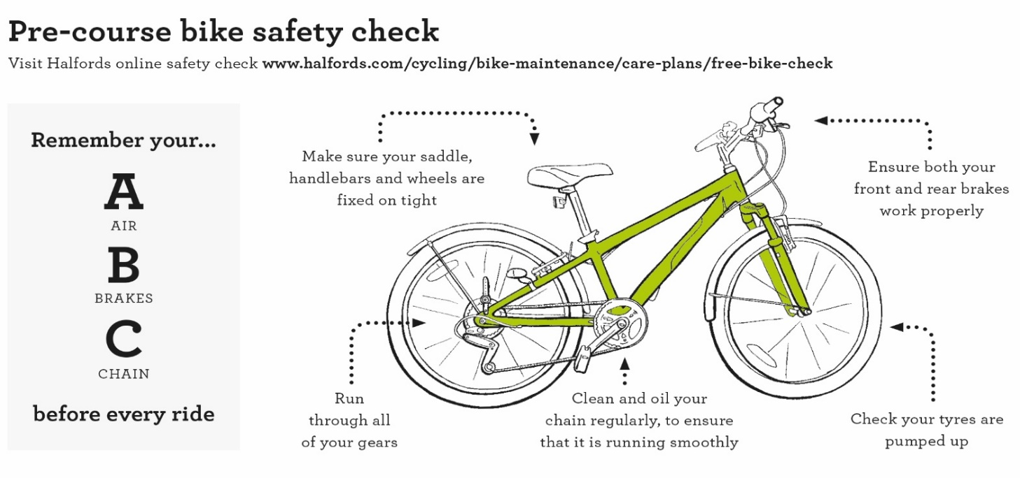

Community information

Derbyshire Constabulary

Hello, please see the attached final agenda for the Police and Neighbourhood Watch event to be held on 10th April, which has had a change of speaker. ACC Paul Gibson will now be speaking. We are almost fully-booked, so if you were intending to come, please reply to alert@neighbourhoodalert.co.uk. You will need ID on the night - regards Gill Riley
Derbyshire Neighbourhood Watch General Meeting and Police event at 5-45pm on 10th April 2019 in the New Building Atrium, at Derbyshire Constabulary, Butterley Hall, Ripley, DE5 3RS
Agenda
5-45pm Open for networking.
6-00pm Cold buffet and beverages.
6-30pm Introduction by Joey Severn, Press Office.
6-35pm Assistant Chief Constable Paul Gibson.
6-45pm Police & Crime Commissioner Hardyal Dhindsa – Innovation Fund
6-55pm Report from DNWAT Chair Lynn Farrar.
7-00pm CEO of National NW - John Hayward-Cripps / Short Q&A session.
7-15pm Chief Superintendent Adrian Gascoyne – Reform and Engage Stakeholder Presentation / Q&A s
7-45pm Sgt James Shirley – Rural Crime / Short Q & A session.
8-10pm PC Adam Shipley – Dash Cam footage / Short Q&A session.
8-35pm PC Phil Draycott – Update on the drugs scene in Derbyshire / Short Q&A session
9-00pm Event ends.

Derbyshire County Council
Road Safety Officers will be available to check child car seats at the following locations:

- Tuesday 9 April 2019 at East Midland Designer Outlet from 10am to 1:30pm
- Monday 13 May 2019 at Morrisons, Buxton from 10am to 1:30pm

All checks are free and there is no need to book and appointment, staff carrying out the checks are trained to Institute of Occupational Safety and Health standards. For further information contact Derbyshire County Council Road Safety Team on 01629 538060, roadsafety@derbyshire.gov.uk or visit https://derbyshire.gov.uk/home.aspx

Reminders
Biggin WI – meets in Biggin Village Hall the second Monday of the month
Hartington Social Dance Club - sequence dancing each Wednesday evening (mid-September to mid-June) in Hartington Village Hall.

