Biggin C of E Primary School

Newsletter for the first Summer Term (29/04/19 – 24/05/19)
Published Monday 29th April 2019

Welcome back after the Easter holiday. I hope you managed to enjoy the sunshine and a well-earned rest. The children have settled back into school and are excited by all the plans for our learning this term.
The summer term is always a busy one and is also important for completing statutory tests in Years 1, 2 and 6. We appreciate all your support keeping attendance high and making sure the children arrive promptly for the start of the school day at 8.50am.
Today’s years 3 and 4’s tennis at QEGS has been moved to 10th May. We have a packed sporting calendar for the summer term, with orienteering and a mini tennis competition also for Years 3 and 4 next week and more exciting opportunities to follow.
On Wednesday the whole school are visiting Lower Hurst Organic. Although this is on our doorstep it offers a fantastic trip where children can learn about a flourishing local business, beef farming and the skills a farmer needs on a modern farm, organically raising animals and how our food reaches our plate. They children have already begun researching from the website and thinking about their questions prior to the visit.
Drama Club continues after school on Tuesday and Derby County commence their club on Thursdays, 3.30 - 4.30pm.
Parents of Year 6 children are invited to a short meeting at 4.30pm on Thursday to discuss their forthcoming trip to London on 21st June.
Finally a very warm welcome back to Ms Wotton who is starting a phased return this week.

Safeguarding Reminder:
If you or any member of the public are concerned about the safety and wellbeing of a child, please call Starting Point at Derbyshire County Council on 01629 533190.

Do you know what to report to the police and when to contact your local council office? On the web link below you can find out the most convenient ways to report crimes, incidents or neighbourhood problems to either Derbyshire police or its partners. Use the icons in the centre of the page to find the most relevant topic and way to report your specific issue http://www.derbyshire.police.uk/Contact-Us/Contact-Us.aspx

Congratulations!
to Mrs C Wager on winning the Bonus Ball draw for Saturday 13th April with number 30 and
to Mr L Fentem on winning the Bonus Ball draw for Saturday 20th April with number 4 and
to Miss E Prince on winning the Bonus Ball draw for Saturday 27th April with number 10.

For this week: 29th April to 3rd May
Monday Beaumont to collect unwanted clothing
Tuesday NO after-school drama club / shortlisting
Wednesday Whole school visit to Lower Hurst Farm
Thursday 3.30pm – 4.30pm: after-school sport club for those in years 2 – 6
4.30pm meeting for Y6 and parents to finalise the London trip
Friday Collective Worship with Michael Tinker
Friday
Dinner money for the Summer term
£39.90 29th April to 24th May minus Bank Holiday 6th May
£73.50 3rd June to 19th July (Y6 = £67.20 as you will be at Q.E.G.S. for three days)
You may send in any amount you like –split the two now? Remembering that it should be paid in advance please either in cash or by a cheque made payable to DCC.

And for next week: 6th – 12th May
Monday Bank Holiday Monday (school closed!)
Tuesday After-school drama club / interviews
Wednesday After-school mini-tennis for years 3 & 4 at Q.E.G.S.
Thursday Orienteering at Ashbourne recreation ground for years 3 & 4
After-school sport club for those in years 2 - 6
Friday Tennis for years 3 & 4 at Q.E.G.S.
Collective Worship with Julia Hewgill

Friday
Bikeability for year 6 pupils within the school day.
Level One Monday 13th May, Level two Tuesday 14th May and a full day to be confirmed. To participate, your child must have a normal cycle helmet (not motorbike, BMX etc), a road-worthy bicycle – see pre-course safety check.
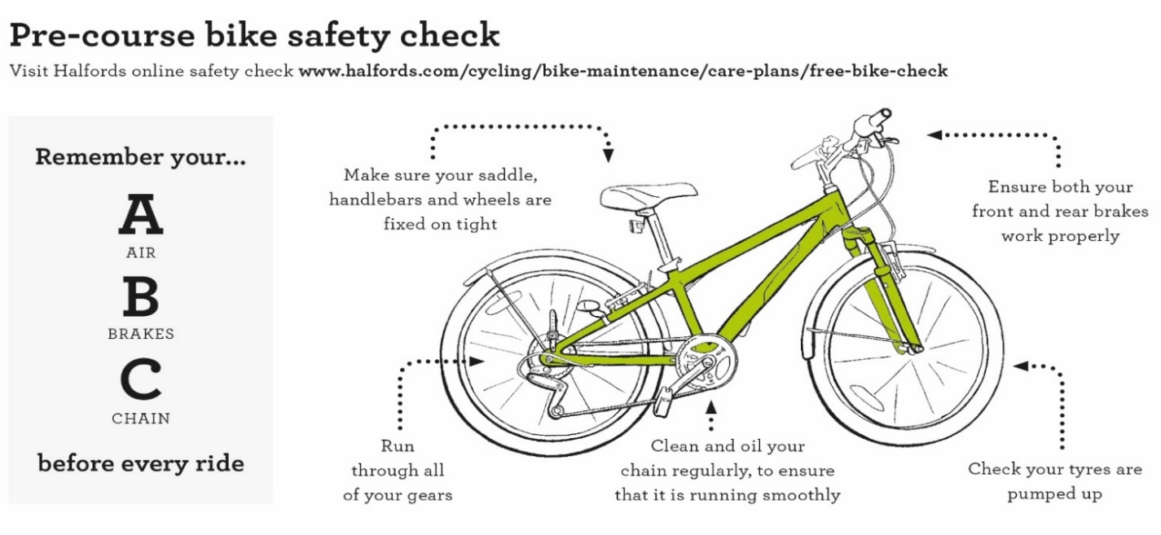

Permission slips for Summer term one events out-of-school
- within school hours unless specified
- if your child has a school meal, this will be provided as a packed lunch on the whole school/day trips
- transport is always provided

Wednesday 8th May years 3 & 4 tennis at Q.E.G.S. after-school 4pm – 6pm
Thursday 9th May years 3 & 4 orienteering at Ashbourne recreation ground
Friday 10th May years 3 & 4 tennis at Q.E.G.S.
Wednesday 15th May KS2 to Parwich for a mini-sport event
Friday 17th May whole school/day to St. Luke’s
Wednesday 22nd May KS2 to Clifton Cricket Ground for kwik-cricket
Friday 24th May years 5 & 6 to Q.E.G.S. for quadkids (athletics)

Separate letters are attached for Lower Hurst Farm and Y6’s bikeability course.

Pupil name/s __________________________________________________________

I give permission for my child/ren to attend all the relevant events above, I do not give permission for my child/ren to attend events that I have crossed out.

My name _________________________________ relationship to child/ren ___________________________

Signed ___________________________________ dated _________________________

Permission slips for events out-of-school
- within school hours unless specified
- if your child has a school meal, this will be provided as a packed lunch on the whole school/day trips
- transport is always provided

Wednesday 8th May years 3 & 4 tennis at Q.E.G.S. after-school 4pm – 6pm
Thursday 9th May years 3 & 4 orienteering at Ashbourne recreation ground
Friday 10th May years 3 & 4 tennis at Q.E.G.S.
Wednesday 15th May KS2 to Parwich for a mini-sport event
Friday 17th May whole school/day to St. Luke’s
Wednesday 22nd May KS2 to Clifton Cricket Ground for kwik-cricket
Friday 24th May years 5 & 6 to Q.E.G.S. for quadkids (athletics)

Separate letters are attached for Lower Hurst Farm and Y6’s bikeability course.

Pupil name/s __________________________________________________________

I give permission for my child/ren to attend all the relevant events above, I do not give permission for my child/ren to attend events that I have crossed out.

My name _________________________________ relationship to child/ren ___________________________

Signed ___________________________________ dated _________________________

Community information

Derbyshire Constabulary

Derbyshire County Council
Road Safety Officers will be available to check child car seats at the Buxton branch of Morrisons on Monday 13th May 2019 from 10am to 1:30pm

All checks are free and there is no need to book and appointment, staff carrying out the checks are trained to Institute of Occupational Safety and Health standards. For further information contact Derbyshire County Council Road Safety Team on 01629 538060, roadsafety@derbyshire.gov.uk or visit https://derbyshire.gov.uk/home.aspx

Reminders
Biggin WI – meets in Biggin Village Hall the second Monday of the month
Hartington Social Dance Club - sequence dancing each Wednesday evening (mid-September to mid-June) in Hartington Village Hall.

