Biggin C of E Primary School

Newsletter for the first Summer Term (29/04/19 – 24/05/19)
Published Tuesday 7th May 2019

Our Summer term is now well underway. The whole school enjoyed a fantastic trip to Lower Hurst Organic Farm on Wednesday last week. It was such an interesting and fun day and great to see an important local business close up. Hopefully you have had chance to try out the delicious meatball recipe the children brought home! The farm are having an open Sunday on 9th June which should be a lovely family event if you want to go for a free visit.
All the children have been observing flowering plants for our 'Living and Growing' topic and have been busy planting seeds for our entry into the Chatsworth 'Schools Sensory Planters Competition' in June.
The next two weeks continue to be very busy with statutory testing taking place for Years 2 and 6 but we are all looking forward to a return visit to St Luke's Primary School in Glossop on 17th May. (Their Year 5 and 6 children visited us in November before the RE conference at Hartington). This time we will experience what it is like to work in a larger school, enjoy taking part in their sports day and work on Drama about character education in the afternoon.
A quick reminder - the FOBS race night is now on Friday 14th June in Biggin Village Hall. Please join us for a really exciting event which will hopefully raise lots of money for school.

Safeguarding Reminder:
If you or any member of the public are concerned about the safety and wellbeing of a child, please call Starting Point at Derbyshire County Council on 01629 533190.

Do you know what to report to the police and when to contact your local council office? On the web link below you can find out the most convenient ways to report crimes, incidents or neighbourhood problems to either Derbyshire police or its partners. Use the icons in the centre of the page to find the most relevant topic and way to report your specific issue http://www.derbyshire.police.uk/Contact-Us/Contact-Us.aspx

Congratulations!
to Mr D Prince on winning the Bonus Ball draw for Saturday 4th May with number 41

Dinner money for the Summer term
£39.90 now over-due, £73.50 for 2nd summer term (Y6 = £67.20 as you will be at Q.E.G.S. for three days).

Generally…
Tuesday Sport with RuggerEds
3.30pm – 4.30pm: after -school drama club
Thursday Violin lesson for Y3 pupils
Sport with Derby County coaches
3.30pm – 4.30pm: after-school sport club for those in years 2 – 6

Additionally this term: -
Wednesday 8th After-school mini-tennis for years 3 & 4 at Q.E.G.S
Thursday 9th Orienteering at Ashbourne recreation ground for years 3 & 4
Friday 10th Tennis for years 3 & 4 at Q.E.G.S.
Friday
Monday 13th SATs / Y6 bikeability 1/4
Tuesday 14th SATs / Y6 bikeability 2/4 & after-school to 4.30pm
Q.E.G.S. completed information to be here if you wish school to post it on for you
Wednesday 15th SATs / Scholastic orders by today
Thursday 16th SATs / Y6 bikeability ¾ & & after-school to 4.30pm
Friday 17th Whole school/day visit to St Luke’s

Wednesday 22nd Kwik Cricket at Clifton – all KS2
Friday 24th Church service at 09:10 / Y5 & 6 quadkids at Q.E.G.S., break up for half-term

Return to school on Tuesday 4th June – Monday 3rd June is an INSET day where school is closed to pupils
to allow for staff training.

Friday
Bikeability for year 6 pupils within the school day.
Level One Monday 13th May, Level two Tuesday 14th May and a full day to be confirmed. To participate, your child must have a normal cycle helmet (not motorbike, BMX etc), a road-worthy bicycle – see pre-course safety check.
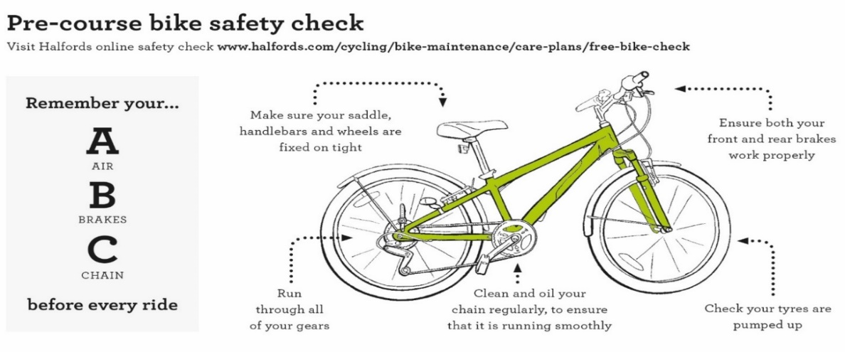

Scholastic - please ensure that all orders are in the office before Thursday 16th May and we will try to get your orders back before we break for the half-term holiday

Y6 booklet from Q.E.G.S. - please read though and compete pages 17 – 22, you may drop them off at school by Tuesday of next week (14th May) if you wish us to post them on for you.

Community information

Derbyshire Constabulary

Derbyshire County Council
Road Safety Officers will be available to check child car seats at the Buxton branch of Morrisons on Monday 13th May 2019 from 10am to 1:30pm

All checks are free and there is no need to book and appointment, staff carrying out the checks are trained to Institute of Occupational Safety and Health standards. For further information contact Derbyshire County Council Road Safety Team on 01629 538060, roadsafety@derbyshire.gov.uk or visit https://derbyshire.gov.uk/home.aspx

Reminders
Biggin WI – meets in Biggin Village Hall the second Monday of the month
Hartington Social Dance Club - sequence dancing each Wednesday evening (mid-September to mid-June) in Hartington Village Hall.

