Biggin C of E Primary School

Newsletter for the first Summer Term (29/04/19 – 24/05/19)
Published Monday 13th May 2019

After a busy week where Year 3 & 4 children were playing tennis and our Year 5 and 6 children were doing lots of science work, this week remains just as busy!
Year 6 are completing statutory tests and bikeability sessions and the whole school is off for a return visit to St. Luke's C of E Primary School in Glossop on Friday. We'll be joining them for sports in the morning and in the afternoon doing workshops on music and art for key stage 1 and character education for key stage 2.
Year 2 are also starting some tests which are statutory this week.
Next week, Year 6 will be thinking about transition with a member of the QEGS team visiting school and on Friday, Years 5 and 6 will enjoy quad kids activities. This term is such an important and busy time for all of our children so please make sure attendance remains high.
Last week we were very busy with recruitment. I am pleased to announce Mrs Anne Bunting and Miss Charlotte Ironmonger will join the team as teaching assistants and Mrs Amanda Miles will join the team as Senior Business Officer. I'm sure you will join me in welcoming them and wishing them every success in their new roles.

Safeguarding Reminder:
If you or any member of the public are concerned about the safety and wellbeing of a child, please call Starting Point at Derbyshire County Council on 01629 533190.

Do you know what to report to the police and when to contact your local council office? On the web link below you can find out the most convenient ways to report crimes, incidents or neighbourhood problems to either Derbyshire police or its partners. Use the icons in the centre of the page to find the most relevant topic and way to report your specific issue http://www.derbyshire.police.uk/Contact-Us/Contact-Us.aspx

Congratulations!
to Mrs J Riley on winning the Bonus Ball draw for Saturday 11th May with number 24

Dinner money for the Summer term
£39.90 now over-due, £73.50 for 2nd summer term (Y6 = £67.20 as you will be at Q.E.G.S. for three days).

Generally…
Tuesday Sport with RuggerEds
3.30pm – 4.30pm: after -school drama club
Thursday Violin lesson for Y3 pupils / Sport with Derby County coaches
3.30pm – 4.30pm: after-school sport club for those in years 2 – 6

Additionally this term: -
Monday 13th SATs / Y6 bikeability 1/4
Tuesday 14th SATs / Y6 bikeability 2/4 & after-school to 4.30pm
Q.E.G.S. completed information to be here if you wish school to post it on for you
Wednesday 15th SATs / Scholastic orders by today
Thursday 16th SATs / Y6 bikeability ¾ & & after-school to 4.30pm
Friday 17th Whole school/day visit to St Luke’s – PE kit, tracksuit bottoms, trainers and school sweatshirt to be worn. Lunch – school meal there or bring your usual packed lunch.
Sunday 19th 2pm – 4pm free taster session at Ashbourne Tennis Club (Gateway Park)

Wednesday 22nd Kwik Cricket at Clifton – all KS2
Friday 24th Church service at 09:10 / Y5 & 6 quad-kids at Q.E.G.S., break up for half-term
Sunday 26th 2pm – 4pm Biggin Jumble Sale, tea and cakes in the village hall.
Contact Sandra on 84695 or Julia on 07745385178 to book a table at £5.00,

Return to school on Tuesday 4th June – Monday 3rd June is an INSET day where school is closed to pupils
to allow for staff training.

Friday
Bikeability - Yr 6 pupils within the school day.
Level One Monday 13th May, Level two Tuesday 14th May and after-school Tuesday and Thursday. To participate, your child must have a normal cycle helmet (not motorbike, BMX etc), a road-worthy bicycle – see pre-course safety check.

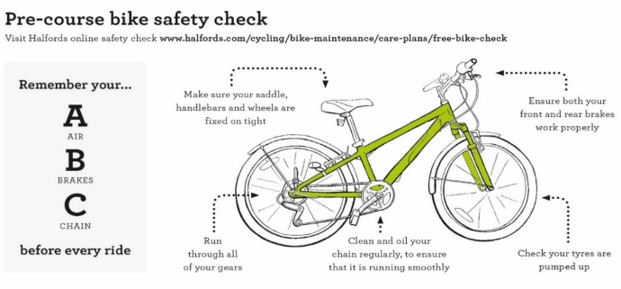

Scholastic - please ensure that all orders are in the office before Thursday 16th May and we will try to get your orders back before we break for the half-term holiday

Y6 booklet from Q.E.G.S. - please read though and compete pages 17 – 22, you may drop them off at school by Tuesday of next week (14th May) if you wish us to post them on for you.

Tennis – Ashbourne tennis club are offering a free taster session on Sunday 19th May 2.00pm to 4.00pm at Peak Gateway Leisure Park, Moor Lane, Ashbourne DE6 1NA.
Holiday camps are also being run during the summer: -

- 31st July, 1st & 2nd August
- 28th, 29th & 30th August.
These are priced at £15.00 per day with a 20% discount for a full week (3 day) booking. Book online at ashbournetennis.org.uk

Community information

Derbyshire Constabulary

Derbyshire County Council
Road Safety Officers will be available to check child car seats at the Buxton branch of Morrisons on Monday 13th May 2019 from 10am to 1:30pm

All checks are free and there is no need to book and appointment, staff carrying out the checks are trained to Institute of Occupational Safety and Health standards. For further information contact Derbyshire County Council Road Safety Team on 01629 538060, roadsafety@derbyshire.gov.uk or visit https://derbyshire.gov.uk/home.aspx

Reminders
Biggin WI – meets in Biggin Village Hall the second Monday of the month
Hartington Social Dance Club - sequence dancing each Wednesday evening (mid-September to mid-June) in Hartington Village Hall.

