Biggin C of E Primary School’s
Monday 9th July 2018
Newsletter 6 for Summer Term Two: 4th June - 20th July 2018

Congratulations!

to Mrs Gosney as Bonus Ball number 1 was drawn on Saturday 7th July.

Well, I’m sorry but I have to say…. we try very hard to fit your parent evening consultation times to your request and then you suddenly, on the night can’t make it!

Sports Evening – Monday 16th July
Would you please send in donations for the fundraising stalls? We need: -

- Bran tub items
- Unwanted gifts
- Donations toward games e.g. chocolates, sweeties etc...
- Prizes for games
- Raffle prizes
- Cakes for cake stall

Thanking you in advance – you may have realised that due to our fundraising activities you have not had to pay anything toward the visit to Conkers or for your child to go to London! Transport to the pantomime is provided, we subsidise the Whitehall residential & seats at the pantomime. Hopefully you will agree that it is worth doing & a little effort spread throughout makes it easier for all and everyone benefits. We realise that not everyone can man a stall but that is where the donators come in! Everyone helps in a variety of ways.

Summer term Two 2018
Wednesday after-school Music club for those in years 4, 5 & 6
Thursday afternoons: - Violin lessons for those in year 3
- Derby County sport coaching for all
Thursday after-school sport coaching with Derby County for those in years 1 – 6

Tuesday 10th July KS2 to Bakewell to participate in a concert, transport provided
Thursday 12th July i) ‘Show & Tell’ for Alex (Yr6) & Ruby
ii) after-school Rounders for years 5 & 6
Friday 13th July Mini-Olympics for KS1 – transport provided
Saturday 14th July Biggin Football Fun Day – playing field

Monday 16th July Sports Night on the school field 18:00 – all to attend in PE kit
Tuesday 17th July Leavers’ Concert in the village hall 14:00 followed by refreshments at school
Thursday 19th July a) Mrs Gosney’s Leaving Day at school
b) ‘Show & Tell’ Alyssa & Jacob A (Yr6), Edie, Harvey, Caelan, Ethan & Casey
c) Pupils break up for the summer
Friday 20th July INSET day

‘Show and Tell’ Thursdays
Year 6 to provide a 20 minute presentation; everyone else - just 5 minutes for one item please!
To fit everyone in, we will have a two-in-one session on the final Thursday morning.

12th July Alex (Yr6) & Ruby
19th July a) Alyssa (Y6) & Jacob A’s presentation
b) Edie, Harvey, Caelan, Ethan & Casey

DEBTS
There are a number of pupils with dinner money debt. Please ensure £________ is received in the school office by the end of this week, cash or a cheque made out to Biggin School please. This amount is what you owed on Friday 6th July plus £10.00 for this week and £8.00 for next week.

There are a number of pupils whose dinner money will be over-paid by the end of next week, would you like to just carry this amount forward to September or would you like a refund of £_______?

Biggin Football Fun Day

Please go along to the playing field on Saturday 14th July for a day filled with fun and games.

Mobile Library Van

Please ensure all library books are in school before Tuesday 17th July.

To contact school and/or reply to messages: - send a note via pupil-post (or leave it in the letter-box), email info@biggin.derbyshire.sch.uk, pop into the office, or leave a ‘phone message on 01298 84279

Please see the school’s website on www.biggin.derbyshire.sch.uk for the weekly newsletter, calendar and lots of information. Is there anything in particular that you would like to access on here?

Community notices

Look forward to a summer of family fun
Hello - wondering how you’ll keep the kids entertained this summer? Don’t worry – we’re here to help! Carry on with your Wild Challenge activities this summer

Have fun outdoors - and get closer to nature - tell us what you get up to and work towards the Bronze, Silver and Gold awards. We’ll be with you all the way, sending a weekly email packed with wild activity ideas. From 30 July to 5 August, watch out for Wild Challenge Week as we have great prizes that are courtesy of Aldi up for grabs please visit our webpage for more details.

Here's just a taster of what you could do

Rock pooling | Wild sleepout | Pond dipping

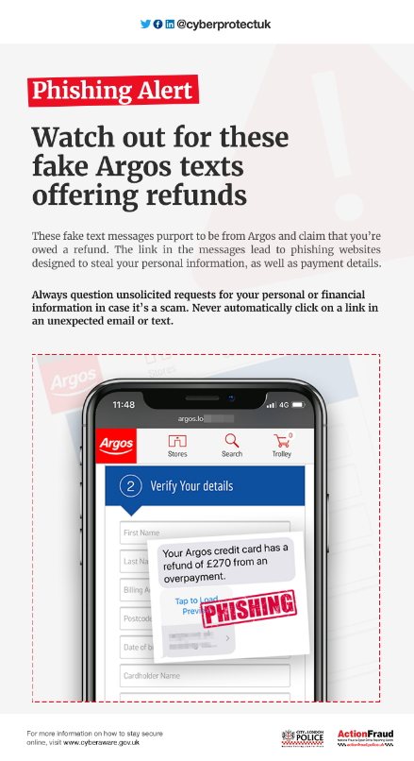
The first-ever police surveillance footage used as evidence in a court case and captured in Derbyshire is to be screened to a global audience at an International Film Festival.
Derbyshire Police and Crime Commissioner Hardyal Dhindsa has agreed to a temporary copyright license giving festival organisers permission to show the short film, Evidence, at the Doclisboa Film Festival held in Lisbon, Portugal, between October 18 and 28 this year.
The rare footage, shot in 1935 from a first floor shop window, captured the activities of a group of street betters in Chesterfield marketplace and is the earliest known police surveillance film to be used as evidence in a criminal prosecution.
Captured by PC Saunders, the historic footage - which also captured a troop of circus elephants and was unearthed at the National Police Training College in Bramshill - is published on the British Film Industry website and gives Derbyshire a unique position in British judicial history.
According to the British Film Industry, the film was shown at Chesterfield Police Court on May 13 1935 in the trial of 39 defendants. According to local newspaper reports at the time, the court building had to be transformed into a temporary "cinema" to screen the footage.
Mr Dhindsa said: "‘I am very proud of Derbyshire Constabulary's role in legal history and feel privileged to be able to share this historic footage with an international audience.
"Policing has come a long way since those early days and film evidence today including CCTV and body-worn video is routinely used as prosecution evidence in our courts.
"Advances in technology continue to push the boundaries of police investigation and capability and it's humbling to think Derbyshire played such a critical role in this evolution."
Before the film was discovered, a 1938 film of street betters in Bradford was believed to be the oldest example of film evidence being used in a British court.
Following Derbyshire's use of recorded footage, many other forces began to explore the use of moving images as evidence. The film can be viewed on the British Film Industry's website at: https://player.bfi.org.uk/free/film/watch-evidence-1935-online

There is concern that victims of previous Computer Software Service Fraud (CSSF) are being re-targeted for “owed money”. The National Fraud Intelligence Bureau (NFIB) reports that CSSF scammers are returning to contact previous victims, requesting that they pay money owed for a fake malware protection service they had provided. Alternatively, the fraudster will ask for a new subscription fee in return for protection from a new threat. The victims that have made payments to the fraudsters have done so via credit/debit card payments. In some instances threatening and aggressive language has been used against victims, as part of the attempt to coerce them into sending money.
Computer Software Service Fraud involves the victim being contacted, told that there is a problem with their computer, and that for a fee this issue can be resolved. The aim of the fraudster at this point is usually to gain remote access to the victim’s computer and, subsequently, access to their online banking account. No fix actually occurs. The victims will often be cold-called or will receive a pop-up on their computer, prompting them to phone the suspect.
Since the beginning of this year (2018), the total loss for repeat victims of CSSF has been reported as £16,712.85. The National Fraud Intelligence Bureau has noticed an increase in such reports since the beginning of May.

Protect Yourself
• If you receive such an unsolicited call or pop-up, do not make a payment. Always ensure you know who you are talking to. If in doubt, hang up immediately.
• Do not allow remote access to your computer.
• Don’t be rushed or pressured into making a decision. Under no circumstances would a genuine bank, or another trusted organisation, force you to make a financial transaction on the spot; they would never ask you to transfer money into another account for fraud reasons. Remember to stop and take time to carefully consider your actions.
• Listen to your instincts. If something feels wrong then it is usually right to question it. Criminals may lull you into a false sense of security when you are out and about or rely on your defences being down when you’re in the comfort of your own home. They may appear trustworthy, but they may not be who they claim to be.

For more information about how to protect yourself online, visit www.cyberaware.gov.uk and takefive-stopfraud.org.uk

If you have been a victim of fraud or cybercrime, report it to us at Actionfraud.police.uk, or by calling 0300 123 2040.

